It Takes a Network to Raise a Child: Improving the Communication Infrastructure of Public Education to Enable Community Cooperation in Young People’s Success

Mica Pollock

After many years focusing on face-to-face communications in diverse schools, I’ve just finished two years of participation in the OneVille Project, a community design research project engaging people of all ages in exploring the potential of low cost and commonplace technologies (cell phones, computers, free software) for connecting students, educators, families, and community members in youth support efforts in the diverse community of Somerville, MA. I now propose that researchers join educators, youth and families in a central challenge for education research today: figuring out how and when commonplace technologies can support necessary communications between the range of supporters who share students, schools, a district and a diverse community. I call such work improving the communication infrastructure of public education.

In this short essay, I propose a design research agenda that braids equity research and technology research in education. More specifically, I propose that researchers join educators, youth, families, and community partners in tackling a central challenge for education research today: figuring out how, when, and whether to add technologies to diverse educational settings, particularly to support young people who have not yet succeeded in school.

Having long studied face-to-face communications across diverse educational communities (Author 2004, 2008), three years ago I finally noticed the explosion of commonplace technology, used by millions of diverse Americans to communicate outside of school (Watkins 2009). Along with teachers, parents, young people, and others, I’ve since been asking a specific question about such technologies as a design researcher. How, if at all, might low-cost and commonplace technologies enable necessary communications to support young people’s success, between the range of supporters who share students, schools, a district and a diverse community? Encouraging others to ask this question in their local school systems is the purpose of this essay.

By “necessary communications,” I mean communications that enable people to partner in each young person’s full talent development. Any educational community should ideally be a social network working together toward this goal of developing students’ talents (Dewey 1897), but often, the network goes underutilized -- like a city at night, with half of the bulbs gone dark.

In education, social network research (e.g., Daly et al 2010) and social capital research (see, e.g., Putnam 2001, Lin 2001, on a long tradition) suggest that to support young people’s talent development, the people who share educational communities need to communicate information regularly and to build relationships supporting this communication. As Daly et al (2010) sum up, “increased social interaction among all of the school’s stakeholders, is believed to be at the heart of system reform and school improvement” (362). Such research suggests that creating new bridges and links between diverse people of all ages spreads the wealth of local information and connections, key to supporting youth (Putnam 2001). It also suggests that to deepen youth support relationships, communications between diverse stakeholders need to be “denser”—more regular, rather than rare (Daly et al 2010). Much equity-focused research in education argues further that the diverse people who share individual students, classrooms, schools, and communities (Image 1) each have ideas, information, and resources that the others need to know as they try to support young people but too rarely know, due to barriers of relationship, language, and social position (see, e.g., González, Moll, and Amanti 2005). All such literature asks us to inquire whether potential partners – including, the young person – can communicate what the others need to know when they need to know it. If not, can these people really take informed and rapid action to support young people’s success?

Image 1: Possible necessary communication partners in a young person’s life

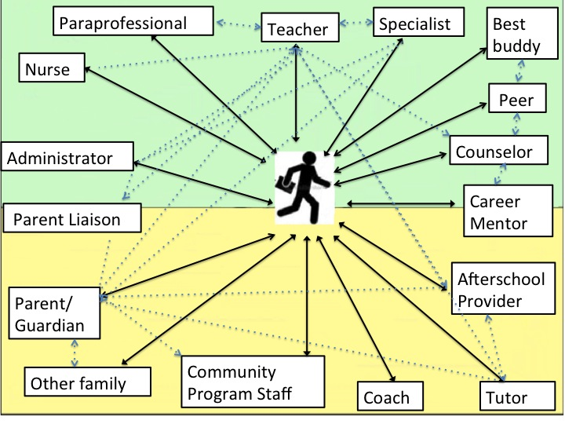

We speak often of students “falling through the cracks” in education, which can imply an unexpected, momentary gap in a human network of information-sharing, relationship, and response. I think it’s more accurate to speak of structural cracks -- communication barriers that routinely block key people from knowing and sharing necessary information.

The people in Image 1 are a conceptual sample of the sorts of people whose everyday acts affect “José.” Each, including José, may know something that can be useful in supporting him (González, Moll, and Amanti 2005). Now, think of rare face-to-face support team meetings between “specialist” and “counselor”; backpack fliers in English from “administrator” to recently immigrated “parent/guardian”; and a “student” rarely asked by “teacher” what he enjoys learning. Each communication habit likely fails to enable potential partners to communicate in necessary ways or in a timely manner about supporting José. If “teacher” knows José is absent regularly but has no idea why, or knows about his love of science but not about a free summer science program for local youth, or if “administrator” doesn’t tell José’s father about an afterschool opportunity available for Jose, there’s a crack in the infrastructure of their partnership.

Embedded barriers to the school communications necessary for partnership abound, particularly in schools serving young people who are low income or not white; such structural cracks can delay potential partners from caring collectively for young people in schools. For example, any shopper with an Internet connection can Google any imaginable product today, but when people in low-income schools need critical data about their children, it is often not so ready or reliable. Research shows that many educators in resource-strapped schools lack tools (or tech support) for accessing basic student data quickly (Aarons 2009, Boudett et al 2005), and that many low-income and immigrant parents too rarely get assisted to see or hear such information about their children’s progress (Taveras et al 2010). While youth of all social groups today use social media to communicate with each other about who they are and what they can do (Ito et al, 2009: Watkins 2009), inside schools, available information about young people’s talents and interests is often not so robust: the student data we now circulate most are test scores alone (Darling-Hammond and Pecheone 2010), and so, many teachers still learn about just a fraction of their students’ actual skills, talents, learning interests, and lives (Pleasants 2008; Nieto 2008; Delpit 2008). Even as many young Americans use phones and computers to communicate nearly instantaneously about personal well-being with friends and family (Ito et al, 2009; Wesch, 2008), personalized updates inside public school communities aren’t typically so rapid or routine: especially with budget cuts, overscheduled educators, specialists, and counselors talk all too rarely about youths’ personal progress and needs (Yonezawa, Jones, and McClure forthcoming). Finally, the opportunity information circulating in low-income schools is notoriously not sufficiently far-reaching. Even in an era of global information-sharing (Shirky 2006), many low-income and immigrant parents and youth remain unaware of educational opportunities available right in their schools or community (Mickelson and Cousins 2008; Yonezawa and Jones forthcoming), due to gaps in tech access, personal connections, and translation (even when legally required; Zehr 2011). This structural crack is a focus of social capital literature (Putnam 2001).

Such cracks in knowledge about young people’s situations and available supports are cracks in partnership for young people’s success. Each crack in infrastructure is caused either by inadequate or inaccessible communication channels, by a failure to organize time (or translation) so that people can talk, by low-quality information, or, by a lack of relationships prompting and motivating people to communicate (and then act) to support young people’s development. Improving communication infrastructure means caulking the cracks -- helping necessary information flow between potential partners, to make successful partnership more likely.

A design research agenda: Improving communication infrastructure to enable necessary communications

By improving “communication infrastructure,” I mean embedding tools, channels, and habits of communicating in schools and districts that enable necessary communications, supporting people to partner more effectively in young people’s talent development. A listserv or hallway bulletin board allowing parents to share information with many others, an online data view (dashboard) allowing administrators to look up student absences quickly during a parent conference, an eportfolio (online portfolio) that invites students to communicate their own “life-wide” accomplishments to teachers, or a multilingual coffee hour with the principal affording biweekly check-ins across language barriers are all examples of communication infrastructure I’ve recently explored. Like adding new roads and showing people how to drive, new communication infrastructure “formally” embeds opportunities to communicate into the everyday life of schools, shaping the ongoing “informal” communications that then occur (building on Coburn, Choi, and Mata, in Daly et al 2010). Communication infrastructure can steer people to communicate face-to-face (a regularly scheduled parent-teacher meeting), on paper (a bulletin board), and using some technology (a tool allowing parents and students to check grades online). Without such infrastructure, necessary communications are less possible or less likely.

I propose that a key design task in education is to figure out which communications in educational communities are necessary, and to test how a combination of tech tools, face-to-face talk, and (for the time being) paper might enable such communications between diverse people. I suggest above that necessary communications are ready/reliable, robust, rapid/routine, and far-reaching, but I also suggest that the “necessity” of any given communication needs to be debated by those trying to support young people. Using a simple number line (Image 2), we might evaluate any communication’s “necessity” by asking a single question: do communications enable people to work together to support each young person’s full talent development, or not? We might then ask more specifically who in a diverse community needs to communicate what to whom in order to support young people and, what barriers prevent such communication; and then, we can test which tools, channels and habits of communication enable these necessary communications.

Image 2: Defining a Necessary Communication in Schools

NOT NECESSARY NECESSARY
---------------------------------------------------------------------------------------------------------------
Away from supporting students’ talent development Toward supporting students’ talent development

In evaluating communications’ “necessity,” we might remember that not all communications assist. Indeed, a set of core tensions will plague us as we test adding technology’s higher-frequency communications to schools. These core tensions include time (should parents email principals without limit?), privacy (should nurses reveal health data to teachers?), relationship (should online tutoring tools replace human tutors?) and money (should teachers hold online office hours in the afternoons to better reach their 150 students, even if some parents can’t afford internet?). We might also remember that tech or no tech, communications only assist if people communicate with “high expectations” for each student’s success, while offering “high help” toward that end (Ferguson 2008).

The rest of this Essay discusses this research agenda as forged in the OneVille Project, a participatory design research effort engaging people of all ages in exploring the potential of low cost and commonplace technologies (cell phones, computers, free software) for connecting people in youth support efforts in the diverse community of Somerville, MA (see http://wiki.oneville.org/main/The_OneVille_Project). From 2009-11, along with local families, youth, teachers, administrators, service providers, community organizers, and graduate students in my own community of Somerville, I came to ask my own version of the design research questions suggested above:

To support young people, who in this diverse community needs to communicate which information to whom?

What are the barriers to that communication, and how might those be overcome?

Which channels (used how), and which efforts to build relationships, might support particular necessary communications between these people?

When might specific forms of commonplace technology help increase community cooperation in young people’s success, by supporting diverse students, teachers, parents, administrators, service providers, and other community members to share ideas, resources, and necessary information and to build relationships? What are the limitations to technology use?

I also learned how school community members can test and embed new communication infrastructure themselves, in collaboration with local academics.

The OneVille Project

Somerville, MA, (population approx. 77,000) is often called a city of three “Villes” -- new immigrants, new gentrifiers, and older working class – and also contains a fourth “Ville” of university students. The city’s public school population represents the diversity, complexity, and typical divisions of a large city, in terms of languages (42, with English, Spanish, Portuguese, and Haitian Creole most common), racial-ethnic groups (with large Central American, Brazilian, and Haitian immigrant populations), and economic groups (with a long working class and college-student history, and recent explosion of young professionals and white middle class families). According to the state, 63% of all students in the Somerville public schools are members of “racial/ethnic minority” groups, and 68% receive free and reduced price lunch. http://profiles.doe.mass.edu/profiles/student.aspx?orgcode=02740000&orgtypecode=5&leftNavId=305&). During the OneVille Project, my own kindergartner was in the public schools as well.

The OneVille Project was supported by the Ford Foundation (Phase 1: 2009-11) with documentation in the third year supported by the Digital Media and Learning Hub of the MacArthur Foundation (Phase 1.5: 2011-12). At heart a participatory action project, OneVille had the public goal of working to enable community cooperation in the success of each young person in a diverse community, by co-designing communication solutions linking the people in young people’s lives. This was my own first foray into participatory “design research,” where researchers participate with community members and practitioners in trying to design a solution to a problem, while studying the effort and its snags and redirecting/iterating accordingly (see, e.g., Penuel et al 2011, Dede 2005, Joseph 2004).

After initial welcome from the Somerville Public Schools and the City, a small initial team of three current/former graduate students, two community organizers, two local technologists, and myself undertook a year of exploratory fieldwork and organizing to understand communication needs and existing efforts in Somerville. Communications with youth and among those closest to youth, and communications across the “Villes,” were our focus. To learn by participation, we first explored how face-to-face dialogue strategies could get diverse parents and their children talking across boundaries hindering partnership, via multilingual parent coffees and family Reading Nights linking people across a school’s magnet and “neighborhood” programs; we then began exploring specific technologies’ potential. I participated as a truly anthropological novice on existing parent listservs and student data spreadsheets, tried texting and social networks with youth, and watched youth and teachers test eportfolio websites, while taking copious fieldnotes on the communications involved and enabled (or not).

Most importantly, in our initial fieldwork we found people who were motivated to improve a particular necessary communication -- teachers wanting to sort student data more easily or reach absent students; administrators wanting to move past paper portfolios; teachers and students wanting to communicate more about students’ learning interests; parents wanting to communicate across languages -- and then shaped specific design projects around these desires. A year in, we divided into six smaller projects testing specific ways that commonplace technology might afford specific necessary communications. More specifically, to help people attend more closely to the development of each young person, we 1) designed a “dashboard” (quick online data view) for communicating ready and reliable basic data from the district’s student information system, to parents, teachers, and tutors; 2) tested “eportfolios” (online portfolios) supporting youth to communicate robust information on their life-wide skills and interests, to teachers and other viewers; and 3) tested student-teacher texting for rapid and routine personal updates. To help people share information, ideas, and resources across schools, we 4) designed a Parent Connector Network supporting multilingual communication across parents and school staff. We also 5) explored methods of improving citywide information-sharing, to inform youth and parents of local educational opportunities, and 6) supported a computer infrastructure initiative attempting to get hardware and computer training to more youth and families. Each design group combined local academics, youth, parents, educators, technologists, and community organizers. Efforts tackled these ecological “layers”:
Image 3 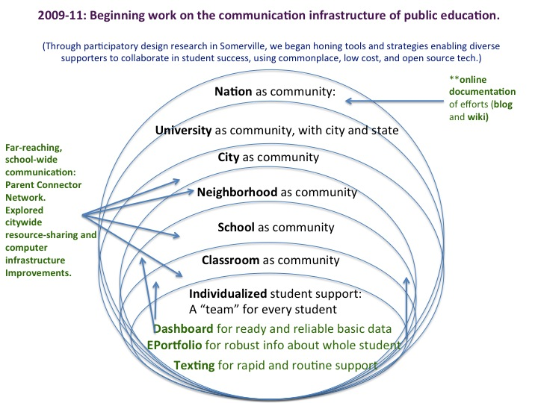

Through trial and error, our participatory design research model became this: to work with teachers, youth, and families to consider necessary communications in a community diverse across lines of race/ethnicity, class, and language, and to test low cost tech tools and communication strategies to see if they supported necessary communications. We also worked to share our efforts publicly online, even if we were still learning (see http://wiki.oneville.org/main/The_OneVille_Project for some ¡Ahas! sparked over time). All of the tech used in the OneVille Project was free/low-cost (e.g., we used many Google tools, and low-cost text messaging) and when we built a couple of new tools because we couldn’t find an existing free tool (our dashboards and hotline), we used open source software to do it (software that any programmer can have and adapt). And while we had begun thinking that a single platform might support all necessary communications at once, we realized over time that we really sought a toolkit of tools and strategies supporting a host of necessary communications in a diverse community – via a hybrid of technology, face-to-face communication, and (for the time being) paper.

All of this work de facto required community organizing as much as basic research, because we had to build serious relationships and tap community and district/school interests to pinpoint desired communications and then, to test anything at all. We worked on the following aspects of communication infrastructure.

Testing Ways of Supporting Necessary Communications: Six OneVille Projects

1. For communicating ready and reliable student information: the dashboard project

In discussions about necessary communications, teachers and administrators said they couldn’t easily view, sort, or discuss patterns in student data because that data was buried in different “fields” in the student information system (SIS), which Somerville couldn’t afford to replace. Administrators had to send data analysis requests to a central office, or, teachers created their own Excel spreadsheets of data from the SIS and analyzed them by hand. Unable to see different kinds of student data at the same time in a single display, people wasted hours flipping between screens, file folders, spreadsheets, or drawers. In addition, as in many diverse school systems (Taveras et al 2010), while parents could get passwords and log in to check the existing student info system, many immigrant and low-income families were often unsure how to find or read such school information on their children’s absences, grades, or credits. People said all such structural cracks kept people from finding necessary basic information and wasted valuable time.

In response, a teacher, local graduate student, local technologists, and I, with advising parents and staff at the K-8 Healey School, worked to design three open source data dashboards —an administrator data view, a teacher’s classroom view, and, an individual view showing data on a single student to parent, student, and teachers. For the admin and teacher views, we built on an Excel spreadsheet model created by a local parent for an earlier Healey principal (Image 4). For the individual view (Images 5 and 6), we incorporated the school district’s existing report card rubric. I had heard both parents and tutors talk about wanting to discuss children’s skill development more with teachers, so I pushed for adding comment boxes that could allow parent or tutor users to upload ongoing questions or qualitative notes on student service that would then go to the teacher’s email.

Image 4: Administrator and teacher view dashboard

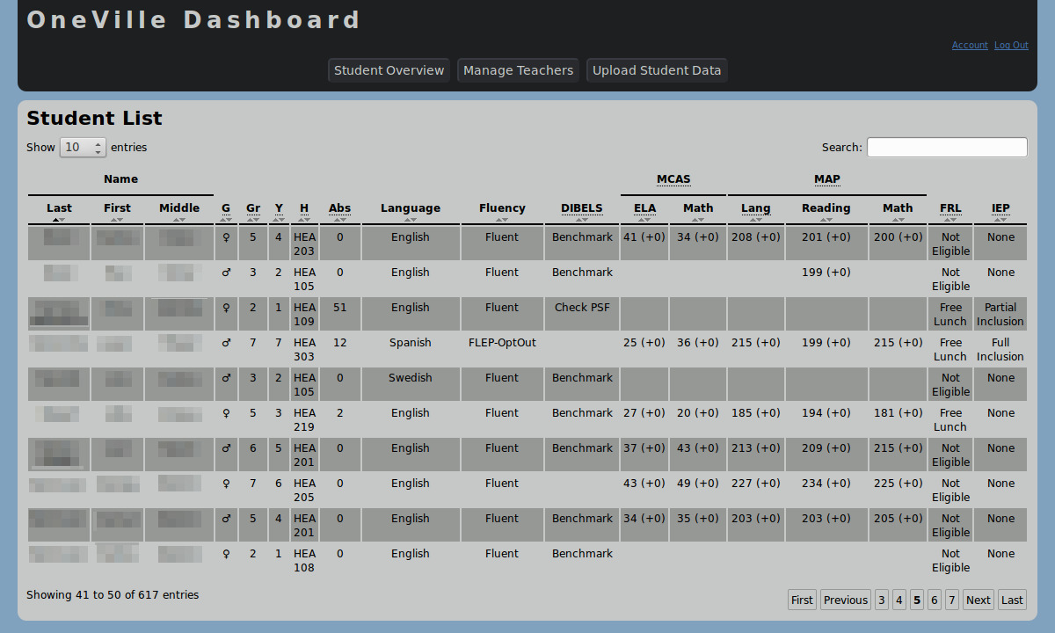

Images 5 and 6: Individualized dashboard views

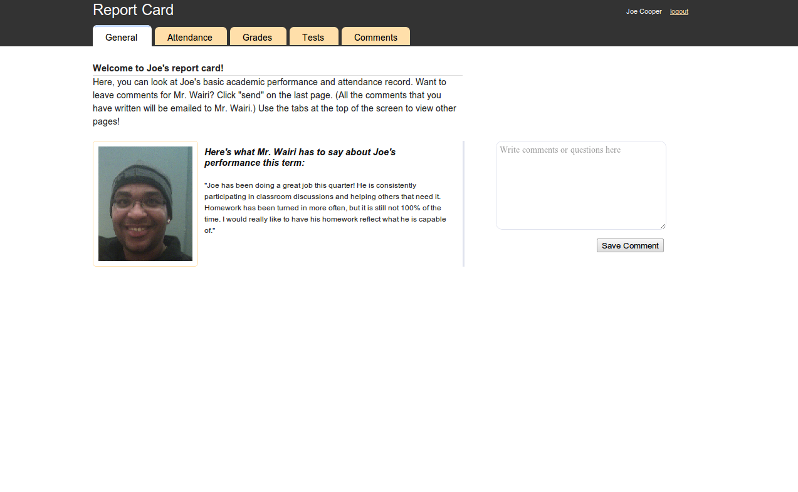
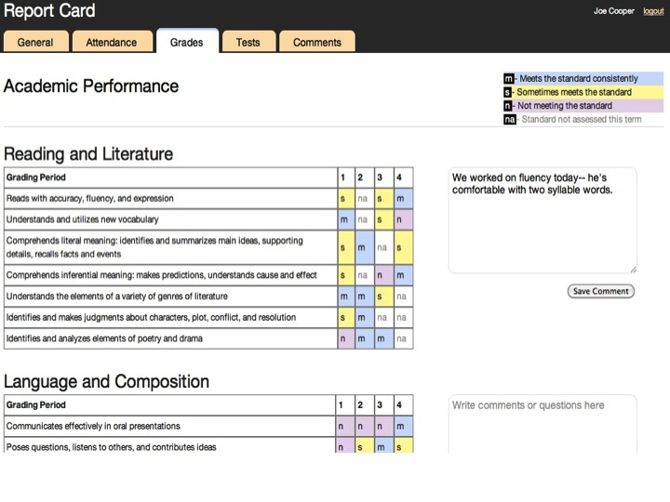
Throughout this effort to support ready and reliable data, we wanted to make a tool that was “free.” As I learned first from Somerville’s local technologists, many tech tools used to share student achievement data are made by for-profit companies and require expensive investment by districts for software, hardware, and tech support. Districts also pay large fees for other software (e.g., for library computers) and for related tech support. So, we used our Ford grant to fund several local technologists to create open source, free tools for the district and then ideally, adaptable elsewhere.

Still, “ready and reliable” data today above all requires reliable programmers and tech support. As it turned out, testing existing, consumer-ready free tools in our other pilots (e.g., texting or Google tools) was far easier and cheaper than making free tools from scratch. Our young local developer, while talented, failed to finish his prototype dashboard on time for a pilot in fall 2011; an even more talented young developer in San Diego then just barely finished the administrator and teacher views pro bono for a very late, brief Spring 2012 pilot. We also learned the hard way that tool creation is not tool adoption: substantial practice time is necessary to seed actual use. I’ve since seen that even in districts with expensive student data systems, many teachers don’t use the tools – often because districts can’t or don’t pay for professional development on how to use them.

In all, the dashboard pilot raised core tensions about designing communication infrastructure for ready and reliable data. Expensive commercial solutions may be more “reliable” than engaging with open source developers trying to support new forms of communication about basic student data for minimal cost; but in an era when anyone can Google any product, for free, there’s also no reason why districts should have to drain scarce resources to access basic data. Designing and piloting low-cost solutions for ready and reliable data access is a key way that equity and tech researchers can together help caulk structural cracks, along with those who need to view data.

Finally, the dashboard project raised another key question about necessary communications, in an era when many schools seek to add tech tools to share scores and stats more quickly (Aarons 2009). What full range of “data” do youths’ supporters need to share in order to support youths’ talent development? To help youth, teachers, and mentors communicate robustly about individual students’ full range of skills, learning interests, and learning experiences, teachers and students at Somerville High School innovated eportfolios using free software.

2. For communicating robust information about the whole student: the eportfolio project.

In fall 2009, we had talked to the SHS principal about his growing interest in exploring electronic portfolios at the school to enable a variety of necessary communications. As one teacher put it, Somerville High School had a paper portfolio tradition that had been largely “a cumbersome collection of paper four times a year.” Portfolios, kept in a locked cabinet, largely contained five-paragraph essays curated by teachers, and were rarely shown to anyone except for formal accreditation visits. In comparison to paper folders, online portfolios could hold more documentation of student skills (videos, links) and, allow students to communicate their skills to more supporters (mentors, admissions officers, employers).

Over a year and a half of careful groundwork with the School Site Council, and then two semesters of participatory afterschool design sessions with a small OneVille team and dozens of students and teachers, SHS’s own diverse youth and educators tested out free software (Googlesites, Wikispaces, and Posterous) for communicating who they were and what they could do. They decided not to simply post school assignments by subject (“Algebra,” “English”), but to use a “Verified Resume” rubric (developed by Arnold Packer) that offered categories for communicating youths’ 21st century skills across subjects. These new categories for posting evidence of one’s skill at e.g. “creativity,” “teamwork,” or “analyzing information” also encouraged students to communicate what they could do outside of school. Student portfolios presented in a spring 2011 community expo included what participants deemed truly new communications about students’ identities and strengths: videos of students narrating their original poetry, solving math equations, doing physics, and learning to skateboard; interviews with teachers evaluating students’ negotiation skills; photos and commentary on students’ original art and work experiences, including their skills in engineering, carpentry and dress design; and class assignments students found particularly valuable to their learning.

One early student designer spoke of the communications about students’ skills and talents that the eportfolio infrastructure newly made possible: https://sites.google.com/site/shseportfolio/eportfolio-video-tutorials/vanessa-s-take. As a student put it in another presentation, an eportfolio allowed her to “show all of the sides of who I am, in one place,” to communicate “little cool things about me” as well as evidence of “being a good student.” A teacher noted how getting such new information could transform teaching practice: if students entered his class at the beginning of the year with eportfolios communicating their skills and interests, learning would be “so much more individualized” (see also Klimczak et al, forthcoming).

But the tech tool itself – e.g., a Googlesite -- was only one part of enabling such necessary communication; an eportfolio could just have hosted students’ five paragraph essays online. Alongside the new rubrics encouraging students to share their full range of skills, students clarified the importance of face-to-face conversations with supporters who motivated young people to recognize and share their own talents. One student, a Spanish speaker, felt encouraged by teachers to post her original poetry online, her first time sharing it with anyone at all; peers started to praise it and to want to post their own. She called the experience transformative, precisely because no one had ever seen or valued this set of her talents publicly. And as encouragement to communicate work publicly motivated next students to share quality work, the skill to communicate via eportfolios also spread virally across the school as students and teachers showed next designers how to use software. Impressed by youths’ products and excitement, administrators started talking about making eportfolios a schoolwide requirement (https://sites.google.com/site/shseportfolio/), thus embedding newly robust communications about students’ skills and interests into the school’s standing communication infrastructure.

Teachers noted that eportfolios catalyzed more running communication about student work online, but not everyone in Somerville was on computers enough to facilitate truly regular communication with young people using this channel; many youth themselves could access computers only when at school or the library. Further, eportfolios, as sites of best work, were not necessarily places where youth would share their full range of ongoing personal struggles. For such rapid and routine communication about young people’s overall development and well-being, we tried technology’s most common denominator tool: texting.

3. For rapid, routine communication about young people’s needs and well-being: the texting project

A core OneVille goal was to figure out how to assist as-needed communications between youth and their key supporters, a group we envisioned as a personal “support team” for every student. In a district summer school English class in 2009, we had first tried unsuccessfully to seed an online social network allowing youth, a “support team,” and teacher to communicate on demand. Participating students argued both that empty online social networks weren’t compelling enough to spark communication and that text messaging was the quickest and most reliable way to reach them. Two teachers and their 40 students at Full Circle/Next Wave, Somerville’s alternative high and middle school, decided to test how one-to-one texting might support students, teachers, and mentors to communicate rapidly and routinely about students’ personal needs. Many of the school’s students were absent from school often and in need of ongoing personal support, and the principal had himself noted that students responded to texts more quickly than any other channel.

We showed the teachers how to use GoogleVoice, a free texting tool, met with students and teachers to brainstorm basic ground rules for appropriate texting (don’t expect a response after 10 p.m. or before 8 a.m.), and encouraged teachers and students to text whenever useful. GoogleVoice self-documented all texts, allowing teachers, a lead doctoral student, and me to review texts by students’ permission. We conducted regular focus groups with students and teachers to discuss texting’s effects, and we anonymized texts for collective review over two “Research Days.” Soon, teachers and students were texting rapidly and frequently about coming to school on time, completing homework and requirements, and participating in school activities. Texts showed banter and over time, deeper revelations over personal struggles, failures, even a rehab placement. Texts included typical examples like this:

Teacher: Everything ok? 9:30 AM
Student: Ted? 10:39 AM
Teacher: Yup 11:02 AM
Student: Everythings alright I guess im gonna b in tm .. Is there anything I can do to put my grade up for your class 11:05 AM
Teacher: Be on time tomorrow, we'll talk then.

Student: I just left my house right now so I'm going to b late 7:47 AM
Teacher: And I need to know this? 7:48 AM
Teacher: Hurry up! 7:49 AM
Student: Because I don't want you to worry 7:49 AM
Teacher: You miss school regularly silly goose 7:51 AM
Student: I came in all this week and collected points 7:54 AM
Teacher: Get here, we can celebrate 7:55 AM
Student: Hahaha okk I'm on cross street now 7:58 AM

Over time, through call and response on this simplest and hardest to ignore of channels, students and teachers at first skeptical about texting built relationships that many students said made them want to come to school at all (Author and Amaechi forthcoming). In data analysis discussions throughout the year, student and teacher participants analyzed their own texting practices and determined that texting afforded both individualized, timely student support and the ability to strengthen student-teacher relationships outside the school day. Texting afforded short bursts of information that could reach students “any time, anywhere” and also facilitated two-way communication – particularly, student response. Texting prompted informal banter in both directions, and soon, information about “school” mixed with lighthearted communication about student needs and notably, explicit statements of personal support (“you’re a smart kid”; “you can do it!”). Students and teachers said that this ongoing supportive exchange, combined with texting’s seeming privacy (even as all texts were recorded on Google Voice for student safety), made both parties care more for the well-being of the person on the other end of the line. Teachers also noted that far from replacing face-to-face communications, texting outside of school often served as a portal to more informed face-to-face communications inside school. Now, new teachers and students are joining in trying out texting, and testing a group texting tool to enable multiple supporters of students’ choice to communicate at any time. Other youth-serving organizations in the community want to learn more about what texting can afford rapid youth support.

The texting project raised obvious core tensions about potentially harmful communications: students’ safety/teachers’ liability (How might ground rules be set up to shape safe and positive uses of text messaging?), privacy (is it always good that a parent can request a child’s private support texts?), and teachers’ time (should teachers be expected to communicate with students outside the school day?). Still, refusing tech because of these uncrossed frontiers is sort of like refusing the printing press because it could produce dangerous books: the design task for schools is to determine acceptable habits of using tech channels. In the texting project, students and teachers set initial ground rules for their own use of texting; both felt that no “inappropriate” texts were ever sent, and both sides described feeling inspired by the polite and mutually supportive tone of student-teacher texts. There is also no simple answer about technology and time use: while allowing anytime communications expanded the school day, absent students would often answer texts seconds after they were sent, saving teacher hours, and even when tiring of texting, teachers noted that building effective relationships through texting was a net time saver because it made collaboration with students more possible when face-to-face. All of these core tensions about enabling in-school communications through out-of-school technologies are to be debated by design researchers in today’s schools.

So, we tested texting because it was the most common-denominator technology in the community; everyone who wanted to text had phones. But many of Somerville’s low income and immigrant parents didn’t text or use computers yet, or even speak the same language as other partners in youths’ development – which is why to pursue far-reaching communications in our design work with parents, we began with face-to-face and phone call-based communications.

4. Affording far-reaching information: the Parent Connector project.

Many parents and staff at the diverse K-8 Healey School in Somerville were already excited to innovate schoolwide information efforts engaging the school’s families (a collection of all “Villes”); the OneVille Project launched parent efforts at the school the year the School Committee decided to integrate two longstanding, class-divided school programs. We began with the face-to-face parent dialogue strategies of multilingual coffee hours, in which parents took the time to translate to and from the principal in four languages so that all parents could both listen and speak; Reading Nights sharing literacy strategies across both programs’ K-2 classrooms and a Special Education classroom; and parent issue dialogues about the integration decision facing the school. In this, we soon realized the extent of a commonly known problem: language and tech access barriers, and related barriers of relationship, kept many low income and immigrant parents (predominantly, speakers of Spanish, Portuguese, and Haitian Creole) from being equally informed about and included in school events, school improvement efforts, and educational opportunities. An English-dominated listserv had long enrolled only some parents, and those not on it were totally unaware of key issues facing the school community; many handouts streaming home were only in English. While many English-speaking parents emailed teachers and administrators regularly for personalized attention, some immigrant and low-income parents felt they tried at length and in vain to reach their children’s teachers or administrators.

Design research offered a way to tap parents’ innovation and bilingual skill in efforts to cross barriers of language and tech access. After meeting in multilingual coffee hours and Reading Nights, bilingual Healey parents and several staff focused from 2010 forward on designing the Parent Connector Network, an effort to tap parent bilingualism in parent information efforts. In the “PCN,” bilingual volunteer parents (“Connectors”) started making phone calls to recent immigrant parents to explain important school information and hear parents’ questions about the school. They also began to translate key schoolwide information onto a prototype open-source hotline that a MIT technologist designed for free at the suggestion of parents brainstorming how to reach parents not yet on the Internet. The hotline is currently being further developed to allow parents to leave phone messages, to be relayed to school staff by a hotline monitor. Connectors also convinced the school to support a part-time bilingual Parent Liaison at five hours a week to monitor Connector calls, run the multilingual coffee hour, and help schedule interpreters for parent-staff meetings. This year, parents and staff were testing the entire infrastructure model and considering holes in it. Our original conceptual model is below.

Image 7: Modeling necessary infrastructure for multilingual communication

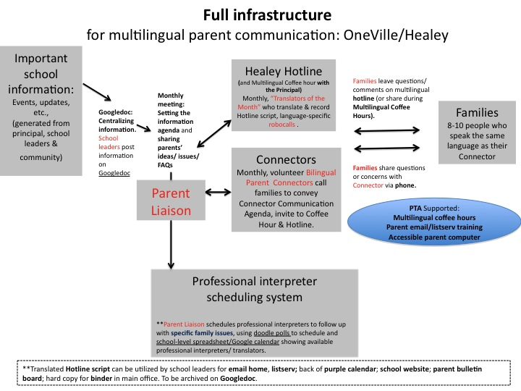

Finally, while the OneVille Project lacked capacity for serious additional efforts, we also networked and brainstormed with city residents and other local researchers interested in citywide information-sharing and supported some Somervillians to begin producing multilingual public videos enabling more youth/families to hear about community resources and events. We also supported some local technologists who were working on low-cost improvements to Somerville's computer infrastructure by refurbishing computers and teaching multi-age classes in a housing project, so that more people could access basic technology and gain basic technology skills to make such communications even possible.

Please see our website for more discussion of each project’s efforts: http://wiki.oneville.org/main/The_OneVille_Project

A design research agenda

Improving communication infrastructure means working to ensure that on a daily basis, the diverse people who need to communicate information and ideas so they can collaborate in young people’s success can do it. Through the trials and triumphs of the OneVille Project, I have come to understand how when educators, youth and families name “necessary communications” and then help design and embed tools and strategies for enabling those communications in their own diverse schools and communities, they make it more normal for ready and reliable, robust, routine and rapid, and far-reaching communications to happen.

Horton and Freire speak of community organizing as “making the road by walking” (1990), and the phrase applies well to participatory design research: in three of our most impactful pilots, by following the lead of community members excited about enabling necessary communications we actually began embedding new communication infrastructure and, so, reshaping everyday communications. Invited to design online portfolios for communicating more robustly about what they could do and who they were, Somerville High School teachers and students brought in totally new rubrics for communicating students’ full range of skills. Brave enough to test a channel many others ban, Full Circle/Next Wave teachers and students began normalizing a tool that could offer rapid and routine updates on personal well-being – practically for free. By creating explicitly multilingual phone networks and coffee hours, Connectors helped normalize the habit of tapping local bilingualism for far-reaching communication. Slowed by the reliable tech support problem in dashboard development, we also had design efforts that didn’t yet successfully catch on. Our most successful efforts tested already-made or user-ready free tools already in people’s hands (e.g., texting), stipended teachers, students, and project leaders to work on designing something they cared about that could then seed as a template, simultaneously seeding local leadership (eportfolio), or tried new ways of tapping people’s energy to innovate ways of including new partners in school work (like Parent Connectors). By actively enabling necessary communications, each effort began embedding communication infrastructure for partnership into a diverse school’s everyday operations.

As people in schools design communication infrastructure, technology can’t be treated as if it will automatically enable necessary communications (Turkle 2011). Instead, researchers and school community members need to test which channels (texting, social network, Googledoc, bulletin board?), which detailed designs of channels (the many “fields” of a dashboard or the rubrics of an eportfolio), and which habits and ground rules for using channels (think norms for texting, or the in-person encouragement behind great eportfolio entries) enable specific necessary communications. While the key question of designing communication infrastructure can remain that suggested earlier in this essay (To support youth’s full talent development, who needs to communicate which information to whom? What are the barriers to that communication? Which tools, channels, and habits might support this communication?), we can ask additional questions to keep ourselves on track as we design and test communication infrastructure:

Are the people who need to be included in a given communication actually included? To work collaboratively, people may have to communicate about the children they share (did José understand the math assignment he did in class or at home?); about the classrooms they share (what’s the homework tonight in José’s classroom?); about the schools they share (what afterschool opportunities are available for children in José’s school?); about the community they share (when is the free science fair?); and even beyond the local community (e.g., with others trying to improve schools where they live). Designers need to ask continually whether necessary partners are able to speak to one another. Further, what Noveck (2009) notes of web tools is true of any communication infrastructure’s design: design shapes participation in a conversation, such that designers need to keep asking whether tools and habits of communicating actually invite necessary partnership. For example, most data displays in education are one-way: parents or youth get to see data, not respond to it or help explain it, and data displays at best prompt service providers to communicate about young people and families rather than with them. We thus pushed ourselves to enable two-way communications in our projects: for example, by creating text boxes on the individual dashboard encouraging parents and tutors to post comments about data that would then go to the teacher’s email. Or, we used channels that were two-way by default: unlike handouts home in backpacks, texts helped spark responses that sparked relationships that buoyed the motivation to communicate further.

Are people able to share forms of information they consider essential to youth support? Asking community members what opportunity information they need available in order to support young people is one key move in designing communication infrastructure. Do José’s parents most need to know how to get him into a popular afterschool program? How to fill out financial aid forms? About local jobs, or health programs? Designers need to ask and to design infrastructure accordingly. Less obviously, as we design “data” plans in schools (Boudett et al 2005; TCR forthcoming), we might also ask youth, teachers, and families to name the information they most want to share and know to support youth more knowledgably. Such information may include how José is doing on algebra quizzes this month, but it also might include how he is doing personally today, what he likes to learn about, or what he does outside of school.

Designing communication infrastructure offers a major leverage point to help bring new information into the conversation, and so, designers need to keep asking which information-sharing truly helps (see Image 2). As with paper or face-to-face conversations (Mehan 1996), tech tools’ categories, blanks, character limits, and instructions shape the conversation about a child. An online (and expensive) “data view” of a child that shows his suspensions next to his face, as I saw demonstrated proudly in one area district, could easily prompt a harmfully negative conversation if this is all educators see or what they see first. (Imagine how the conversation would change if the first thing seen were the student’s poetry). Somerville parents revolted against classroom “data walls” publicly sharing students’ (anonymized) test scores with other children, saying such information distressed and demotivated children rather than motivating them. But countless “data” projects in education focus on sharing more decontextualized scores more quickly with more people (Aarons 2009), forcing us to ask continually when “data “sharing” or “use” harms rather than assists (Darling-Hammond and Pecheone 2010, TCR forthcoming). With database linkage across “sectors” now the rage (Aarons 2009), we must also keep asking questions about who really needs to see which data about young people; is it actually helpful if a teacher sees a student’s arrest record, or his parent’s? (Atlantic Philanthropies, 2012).

When can technologies truly broaden access to necessary communications, rather than widen disparities of access? Most obviously, technology can help people communicate when they can’t meet face-to-face, enabling inclusion (Shirky 2008, Ito et al, 2009). But adding tech channels can at times widen communication inequalities rather than caulk structural cracks (Wilson 2011; Reich et al 2012). Access barriers are like fractals, meaning that they keep replicating in infinite detail: designers seeking equitable access to communications thus need to stay vigilant. All students who wanted to text had phones, but some lost them and couldn’t afford to replace them; some ran out of minutes and literally could no longer talk via text. Money affects the data minutes you can pay for and the speed of a broadband connection; on a closer read, cheap plans enabling broadband access “for all” at times often enable slower communications for some. A schoolwide listserv required new parents to get email accounts, access computers, and learn to use translation software (or, it required peers to translate more information); many recently immigrated parents didn’t know yet how to use a mouse. Though robocalls went home in four languages at once (English, Spanish, Portuguese, and Haitian Creole, in that order), many parents’ machines cut off before the necessary language. (To respond, we asked parents to record targeted robocalls in one language at a time.). Old computers surfed the Internet too slowly and many of the tools needed for creating eportfolio entries weren’t accessible via the library. Quite literally, students with functional home computers could communicate more about who they were and what they could do. So, ensuring equal access to communications each step of the way is crucial to enabling necessary communications – and more broadly, to supporting partnership for young people’s success.

Are communications supporting partnership between diverse stakeholders? Finally, of course, “partnering” in student success requires above all that those who share children become motivated to pursue young people’s success collectively. A text or email can launch a sequence of rapid check-ins with or about a young person, if the check-in is friendly and if recipients respond. A parent might be motivated to share a resource on a well-accessed listserv if she’s seen other parents share resources for the collective benefit. “Partnering” also requires additional action after communication -- actually taking a child to the free science fair after hearing about it on a listserv. So, building the motivation of others to join in the effort to pursue students’ full talent development is really the key to successful partnership. And particularly in diverse communities, building trust and friendship via our communications (Tatum 2008, Cohen 2008, DuBois and Rhodes 2006, Diamond and Gomez 2004) will remain central to building such partnership even as we “add tech.” So, if people treat one another as necessary partners in students’ talent development whenever they communicate, information-sharing and relationship-building can work circularly: through helpful attempts to communicate necessary information, people can come to value each other’s partnership enough to communicate more. Parents told us they came to PTA Night to talk to teachers not just because a robocall invited everyone, but because a peer who spoke their language invited them kindly via the robocall. And as one Parent Connector put it, “relationships are key and they are what make everything work.”

Conclusion

In an era when commonplace technology makes communication easier than ever, the communication infrastructure of public education often seems shockingly antiquated. But at this point in the development of technology use in education, the challenge is not simply to “add more” but to test when blending in technology might enable necessary communications. We know a lot generally about necessary communications in school communities: for example, we know that youth do better when they get regular feedback from teachers on their classroom performance (Hattie 2008) and ongoing personal support from mentors (Yonezawa, Jones, and McClure forthcoming); teachers teach better when youth and colleagues share supportive feedback on improving their teaching (Jones and Yonezawa 2008/2009; Daly et al 2010; Cochran-Smith and Lytle 2009; Boudett et al 2005); parents and teachers support children’s progress better when they communicate often about students’ strengths and struggles (Taveras et al 2010; González, Moll, and Amanti 2005; Lawrence-Lightfoot 2003); families, youth, teachers, and service providers tap local resources better when information about those resources circulates widely (Mickelson and Cousins 2008: Lin and Zaff 2010). All of these processes might be enhanced with some technology. Testing how, when, and if so is a project for design research.

In fact, none of our field’s visionary or equity-minded reforms can occur without designing communication infrastructure enabling necessary communications. “Data-driven” decision-making (Lin and Zaff 2010) requires databases and data displays for sharing reliable and ready information (Boudett et al 2005); how should these tools be designed, and how much should they cost? “Authentic assessment” requires that assessments prompt students to communicate a robust range of their skills (Darling-Hammond and Pecheone 2010); which skills should be communicated? Efforts to “personalize” student learning require getting rapid, routine updates on youths’ development (Yonezawa, Jones, and McClure forthcoming); which updates should be given to whom, how, when in the day? “Engaging” communities and families requires circulating far-reaching information about public resources, events, and opportunities, and public ideas and opinions; how to circulate such information across lines of language, race/ethnicity, income, and tech literacy (Taveras et al 2010, Henderson et al 2007, Mediratta et al 2009)? We need more research examining the channel (Hymes 1972) through which such necessary communications in schools might travel: do teachers share student progress updates with immigrant parents most effectively via phones, email, or in person? Can mentors empower low income youth with college information most effectively via text message, written documents, or face-to-face? What habits of communication should be set if diverse stakeholders are to communicate productively using a listserv, texting, social networks, or even just email?

These are questions for equity and technology researchers to tackle together, in league with diverse stakeholders in public schools. Designing new infrastructure for communication requires careful attention to communication details and consequences, because the communications can become part of the “normal” functions of school. But there’s no question that expecting partnership in education without actively enabling communications between partners is like expecting a network of bulbs to glow without a power cord. It takes a network to raise a child; the tiniest break in the network dims the bulbs. The design question is how to light the network up.

Works Cited

Atlantic Philanthropies, 2012. Race and Gender Disparities in Discipline: a Research-to-Practice Collaborative. Juvenile Justice and Education Stakeholder meetings, Oakland, CA., May 23-24.

Aarons, Dakarai I. 2009. Leading the Charge for Real-Time Data. Education Week, June 3. (online edition).

Boudett, Kathryn Parker, Elizabeth City, and Richard Murnane, eds. 2005. Data Wise: A Step-by-Step Guide to Using Assessment Results to Improve Teaching and Learning. Harvard Education Press.

Cochran-Smith, Marilyn, and Susan L. Lytle. 2009. Inquiry as Stance: Practitioner Research in the Next Generation. New York: Teachers College Press.

Cohen, Geoffrey. L. 2008. Providing Supportive Feedback. In Everyday Antiracism: Getting Real about Race in School, ed. Author, 82-84. New York: The New Press.

Darling-Hammond, Linda, and Ray Pecheone, with Ann Jacquith, Susan Schultz,

Leah Walker, and Ruth Chung Wei. 2010. Developing an Internationally
Comparable Balanced Assessment System That Supports High-Quality Learning. Educational Testing Service.

Daly, Alan J, ed. 2010. Social Network Theory and Educational Change. Cambridge, MA: Harvard Education Press.

Daly, Alan J., Nienke M. Moolenaar, Jose M. Bolivar, and Peggy Burke. 2010. Relationships in reform: the role of teachers’ social networks. Journal of Educational Administration, Vol. 48 No. 3, pp. 359-391.

Dede, C. 2005. Why Design-Based Research is Both Important and Difficult. Educational Technology 45, 1 (January-February), 5-8.

Delpit, Lisa. 2008. Lessons from Teachers. City Kids, City Schools: More Reports from the Front Row. Edited by William Ayers, Gloria Ladson-Billings, Gregory Miche, and Pedro A. Noguera. New York: The New Press, pp. 113-135.

Dewey, John. 1897. My Pedagogic Creed. School Journal 54 (January 1897), 77-80.
Diamond, John B., and Kimberley Gomez. 2004. African American Parents’ Orientations toward Schools: The Implications of Social Class and Parents’ Perceptions of Schools. Education and Urban Society 36(4): 383-427.

Ferguson, Ronald F. 2008. Helping Students of Color Meet High Standards. In Everyday Antiracism: Getting Real about Race in School, 78-81. New York: The New Press.

González, Norma, Luis Moll, and Cathy Amanti (Eds.) 2004. Funds of Knowledge: Theorizing Practices in Households, Communities, and Classrooms. Mahwah, NJ: Lawrence Erlbaum Associates.

Grossman, Jean B., and Meridel J. Bulle. 2006. Review of What Youth Programs Do to Increase the Connectedness of Youth with Adults. Journal of Adolescent Health 39, 788-799.

Hattie, John. 2008. Visible Learning: A Synthesis of Over 800 Meta-Analyses Relating to Achievement. London: Routledge.

Henderson, Anne T., Vivian Johnson, Karen L. Mapp, and Don Davies. 2007. Beyond the Bake Sale: The Essential Guide to Family/School Partnerships. New York: The New Press.

Horton, Myles, and Paulo Freire. 1990. We Make The Road by Walking: Conversations on Education and Social Change. Temple University Press.

Hymes, D. H. 1972. Models of the Interaction of Language and Social Life, in Directions in Sociolinguistics: The Ethnography of Communication, edited by J. J. Gumperz and D. Hymes. New York: Holt, Rinehart & Winston. pp. 35-71.

Ito, Mizuko, et al. 2009. Hanging Out, Messing Around, and Geeking Out: Kids Living and Learning with New Media. Cambridge, MA: MIT Press.

Jones, Makeba, and Susan Yonezawa. 2008. Inviting Students to Analyze their Learning Experience. In Everyday Antiracism: Getting Real about Race in School. New York: The New Press, 212-216.

Jones, Makeba, and Susan Yonezawa. 2002. Student Voice, Cultural Change: Using Inquiry in School Reform. Equity and Excellence in Education, 35:3, 245-254.

Joseph, D. 2004. The Practice of Design-Based Research: Uncovering the Interplay Between Design, Research, and the Real-World Context. Educational Psychologist, 39(4), 235-242.

Klimczak, Susan, Michelle Li, Chris Glynn, and Joe Beckmann, forthcoming. ePossibilities: The Power of a Grassroots Approach to Student-Curated ePortfolios in an Urban High School. Forthcoming in Student-Centered Interactive E-Portfolios in the Cloud, ed. Helen Barrett.

Lawrence-Lightfoot, Sara. 2003. The Essential Conversation: What Parents and Teachers can Learn From Each Other. New York: Random House.

Lin, Nan. Social Capital: A Theory of Social Structure and Action. New York: Cambridge University Press, 2001.

Lin, Emily S, and Jonathan Zaff. 2010. Community Collaborations for Change: Lessons Learned and Directions Forward. America’s Promise Alliance: Unpublished Manuscript.

Mediratta, Kavitha, Seema Shah, and Sara McAlister. 2009. Building Partnerships to Reinvent School Culture: Austin Interfaith. Providence, RI: Annenberg Institute for School Reform.

Mehan, Hugh. 1996. Beneath the Skin and between the Ears: A Case Study in the Politics of Representation. In Understanding Practice: Perspectives on Activity and Context, ed. Jean Lave and Seth Chaiklin. Cambridge: Cambridge University Press.

Mickelson, Roslyn Arlin, and L.L. Cousins. 2008. Informing Parents about Available Opportunities. In Everyday Antiracism: Getting Real about Race in School. New York: The New Press.

Moolenaar, Nienke M., Alan J. Daly, and Peter J.C. Sleegers. 2010. Occupying the Principal
Position: Examining Relationships Between Transformational Leadership, Social Network Position, and Schools’ Innovative Climate. Educational Administration Quarterly
46(5), 623–670.

Nieto, Sonia. 2000. Affirming Diversity: The Sociopolitical Context of Multicultural Education. New York: Addison Wesley Longman, Inc.

Noveck, Beth Simone. 2009. Wiki Government: How Techology Can Make Government Better, Democracy Stronger, and Citizens More Powerful. Washington, DC: Brookings Institution Press.

Oakes, Jeannie, and John Rogers. 2006. Learning Power: Organizing for Education and Justice. New York: TC Press.

Penuel, William R., Barry J. Fishman, Britte Haugan Cheng, and Nora Sabelli. Organizing Resaerch and Development at the Intersection of Learning, Implementation, and Design. Educational Researcher 40 (7), 331-337.

Pollock, Mica, and Uche Amaechi. Forthcoming. Texting as a Channel for Personalized Youth Support: Participatory Design Research by City Youth and Teachers. In review for publication in the Journal of Learning, Media, and Technology.

Pollock, Mica. 2004. Colormute: Race Talk Dilemmas in an American School. Princeton, NJ: Princeton University Press.

Pollock, Mica, 2008. Because of Race: How Americans Debate Harm and Opportunity in Our Schools. Princeton, NJ: Princeton University Press.

Putnam, Robert D. 2001. Community-Based Social Capital and Educational Performance. In Making Good Citizens: Education and Civil Society, ed. Diane Ravitch and Joseph Viteritti. New Haven: Yale University Press.

Reich, B. Justin, Richard Murnane, and John Willett. January/February 2012. The State of Wiki Usage in U.S. K–12 Schools: Leveraging Web 2.0 Data Warehouses to Assess Quality and Equity in Online Learning Environments. Education Researcher, Vol 41, No 1, 7-15.

Shirky, Clay. 2008. Here Comes Everybody: The Power of Organizing Without Organizations. New York: Penguin.

Taveras, Barbara, Caissa Douwes, Karen Johnson, with Diana Lee and Margaret Caspe. 2010. New Visions for Public Schools: Using Data to Engage Families. Harvard Family Research Project, FINE Newsletter, May.

Turkle, Sherry. 2011. Alone Together: Why We Expect More from Technology and Less from Each Other. New York: Basic Books.

Valenzuela, Angela. 1999. Subtractive Schooling: U.S.-Mexican Youth and the Politics of Caring. Albany: State University of New York Press.

Watkins, Craig. 2009. The Young and the Digital: What the Migration to Social Network Sites, Games, and Anytime, Anywhere Media Means for Our Future. Boston: Beacon Press.

Wilson, Ernie. 2011. Diversity in a Digital Age. Berkman Center for Internet and Society, Harvard University, November 10.

Yonezawa, S., McClure, L. and Jones, M. August, 2011. Personalization and Student-Centered Learning. Unpublished paper written for Jobs for the Future, sponsored by the Nellie Mae Foundation.

Zehr, Mary Ann. March 3, 2011. Civil Rights Deal Signals Federal Push for Translation Services. Education Week. Vol 30, Issue 3, pp. 8-9.

With the input of hundreds over two years of effort in Somerville. Particularly but not limited to: Uche Amaechi, Seth Woodworth, Susan Klimczak, Alice Mello, Consuelo Perez, Jedd Cohen, Tona Delmonico, Gina d’Haiti, Sofia Perez, Will Thalheimer, Dave Sullivan, Tracy Sullivan, Michelle Thompson, Josh Wairi, Jen Capuano, Maria Gemma Cruz, Greg Nadeau, Christine Rafal, Bern Ewah, Maria Carvalho, Lupe Ojeda, Rachel Toon, Healey students, Michael Quan, Marisa Wolsky, other Healey parents and teachers, Mo Robichaux, Ted O’Brien, David Willey, Shelia Harris, Full Circle/Next Wave students, Sabrina Trinca, Michelle Li, Chris Glynn, other SHS eportfolio students and teachers, Vince McKay, Tony Pierantozzi, Gretchen Kinder, Jason DeFalco, Purnima Vadhera, Tony Ciccariello, Regina Bertholdo, other PIC staff, Marlon Ramdehal, Lisa Brukilacchio, Mark Niedergang, EliJAH Starr, Caroline Meeks, Franklin DaLembert, Lince Semerzier, Stephanie Hirsch, Sarah Davila, Ana Maria Nieto, Warren Goldstein-Gelb, Rusty Carlock, Barry Stein, Joe Beckmann, Al Willis, and Mark Tomizawa.
I thank Susan Klimczak in particular for this insight.
I thank Uche Amaechi for insisting upon the economics of this point.
One survey researcher put it this way: “Back then ‘digital equity’ meant you were connected or not. Digital equity is now more complicated. It’s ‘do you have a device or not have a device,’ but also, the features and functionalities of your device vs. my device...” (Julie Evans, Learning on the Go: Summit 2012, San Diego, CA, Jan 13, 2012.).
John Bernstein, Learning on the Go: Summit 2012, San Diego, CA, Jan 13, 2012.

